6.2 Constraint Propagation: Inference in CSPs
An atomic state-space search algorithm makes progress in only one way: by expanding a node to visit the successors. A CSP algorithm has choices. It can generate successors by choosing a new variable assignment, or it can do a specific type of inference called constraint propagation: using the constraints to reduce the number of legal values for a variable, which in turn can reduce the legal values for another variable, and so on. The idea is that this will leave fewer choices to consider when we make the next choice of a variable assignment. Constraint propagation may be intertwined with search, or it may be done as a preprocessing step, before search starts. Sometimes this preprocessing can solve the whole problem, so no search is required at all.
The key idea is local consistency. If we treat each variable as a node in a graph (see Figure 6.1(b)) and each binary constraint as an edge, then the process of enforcing local consistency in each part of the graph causes inconsistent values to be eliminated throughout the graph. There are different types of local consistency, which we now cover in turn.
6.2.1 Node consistency
A single variable (corresponding to a node in the CSP graph) is node-consistent if all the values in the variable’s domain satisfy the variable’s unary constraints. For example, in the variant of the Australia map-coloring problem (Figure 6.1) where South Australians dislike green, the variable SA starts with domain
{red, green, blue},
and we can make it node consistent by eliminating green, leaving SA with the reduced domain
{red, blue}.
We say that a graph is node-consistent if every variable in the graph is node-consistent.
It is easy to eliminate all the unary constraints in a CSP by reducing the domain of variables with unary constraints at the start of the solving process. As mentioned earlier, it is also possible to transform all n-ary constraints into binary ones. Because of this, some CSP solvers work with only binary constraints, expecting the user to eliminate the other constraints ahead of time. We make that assumption for the rest of this chapter, except where noted.
6.2.2 Arc consistency
A variable in a CSP is arc-consistent if every value in its domain satisfies the variable’s binary constraints. More formally, Xᵢ is arc-consistent with respect to another variable Xⱼ if for every value in the current domain Dᵢ there is some value in the domain Dⱼ that satisfies the binary constraint on the arc (Xᵢ, Xⱼ). A graph is arc-consistent if every variable is arc-consistent with every other variable.
For example, consider the constraint
Y = X²
where the domain of both X and Y is the set of decimal digits. We can write this constraint explicitly as
⟨(X, Y), {(0, 0), (1, 1), (2, 4), (3, 9)}⟩.
To make X arc-consistent with respect to Y, we reduce X’s domain to
{0, 1, 2, 3}.
If we also make Y arc-consistent with respect to X, then Y’s domain becomes
{0, 1, 4, 9},
and the whole CSP is arc-consistent.
On the other hand, arc consistency can do nothing for the Australian map-coloring problem. Consider the following inequality constraint on (SA, WA):
{(red, green), (red, blue), (green, red), (green, blue), (blue, red), (blue, green)}.
No matter what value you choose for SA (or for WA), there is a valid value for the other variable. So applying arc consistency has no effect on the domains of either variable.
The most popular algorithm for enforcing arc consistency is called AC-3 (see Figure 6.3). To make every variable arc-consistent, the AC-3 algorithm maintains a queue of arcs to consider. Initially, the queue contains all the arcs in the CSP. (Each binary constraint becomes two arcs, one in each direction.) AC-3 then pops off an arbitrary arc (Xᵢ, Xⱼ) from the queue and makes Xᵢ arc-consistent with respect to Xⱼ.
If this leaves Dᵢ unchanged, the algorithm just moves on to the next arc. But if this revises Dᵢ (makes the domain smaller), then we add to the queue all arcs (Xₖ, Xᵢ) where Xₖ is a neighbor of Xᵢ. We need to do that because the change in Dᵢ might enable further reductions in Dₖ, even if we have previously considered Xₖ. If Dᵢ is revised down to nothing, then we know the whole CSP has no consistent solution, and AC-3 can immediately return failure.
Otherwise, we keep checking, trying to remove values from the domains of variables until no more arcs are in the queue. At that point, we are left with a CSP that is equivalent to the original CSP—they both have the same solutions—but the arc-consistent CSP will be faster to search because its variables have smaller domains. In some cases, it solves the problem completely (by reducing every domain to size 1) and in others it proves that no solution exists (by reducing some domain to size 0).

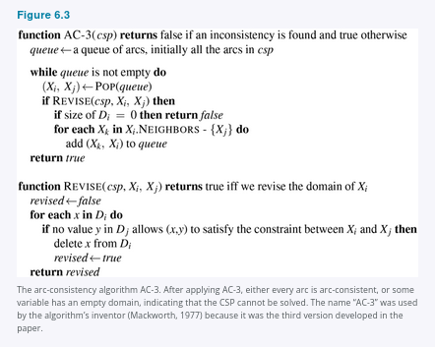
The complexity of AC-3 can be analyzed as follows. Assume a CSP with n variables, each with domain size at most d, and with c binary constraints (arcs). Each arc (Xᵢ, Xⱼ) can be inserted in the queue only d times because Xᵢ has at most d values to delete. Checking consistency of an arc can be done in O(d²) time, so we get O(cd³) total worst-case time.
6.2.3 Path consistency
Suppose we are to color the map of Australia with just two colors, red and blue. Arc consistency does nothing because every constraint can be satisfied individually with red at one end and blue at the other. But clearly there is no solution to the problem: because Western Australia, Northern Territory, and South Australia all touch each other, we need at least three colors for them alone.
Arc consistency tightens down the domains (unary constraints) using the arcs (binary constraints). To make progress on problems like map coloring, we need a stronger notion of consistency. Path consistency tightens the binary constraints by using implicit constraints that are inferred by looking at triples of variables.
A two-variable set {Xᵢ, Xⱼ} is path-consistent with respect to a third variable Xₘ if, for every assignment {Xᵢ = a, Xⱼ = b} consistent with the constraints (if any) on (Xᵢ, Xⱼ), there is an assignment to Xₘ that satisfies the constraints on {Xᵢ, Xₘ} and {Xₘ, Xⱼ}. The name refers to the overall consistency of the path from Xᵢ to Xⱼ with Xₘ in the middle.
Let’s see how path consistency fares in coloring the Australia map with two colors. We will make the set {WA, SA} path-consistent with respect to NT. We start by enumerating the consistent assignments to the set. In this case, there are only two:
{WA = red, SA = blue}
and
{WA = blue, SA = red}.
We can see that with both of these assignments NT can be neither red nor blue (because it would conflict with either WA or SA). Because there is no valid choice for NT, we eliminate both assignments, and we end up with no valid assignments for {WA, SA}. Therefore, we know that there can be no solution to this problem.
6.2.4 K-consistency
Stronger forms of propagation can be defined with the notion of k-consistency. A CSP is k-consistent if, for any set of k − 1 variables and for any consistent assignment to those variables, a consistent value can always be assigned to any kth variable. 1-consistency says that, given the empty set, we can make any set of one variable consistent: this is what we called node consistency. 2-consistency is the same as arc consistency. For binary constraint graphs, 3-consistency is the same as path consistency.
A CSP is strongly k-consistent if it is k-consistent and is also (k − 1)-consistent, (k − 2)-consistent, … all the way down to 1-consistent. Now suppose we have a CSP with n nodes and make it strongly n-consistent (i.e., strongly k-consistent for k = n). We can then solve the problem as follows: First, we choose a consistent value for X₁. We are then guaranteed to be able to choose a value for X₂ because the graph is 2-consistent, for X₃ because it is 3-consistent, and so on. For each variable Xᵢ, we need only search through the d values in the domain to find a value consistent with X₁, …, Xᵢ₋₁. The total run time is only O(n²d).
Of course, there is no free lunch: constraint satisfaction is NP-complete in general, and any algorithm for establishing n-consistency must take time exponential in n in the worst case. Worse, n-consistency also requires space that is exponential in n. In practice, determining the appropriate level of consistency checking is mostly an empirical science. Computing 2-consistency is common, and 3-consistency less common.
6.2.5 Global constraints
Remember that a global constraint is one involving an arbitrary number of variables (but not necessarily all variables). Global constraints occur frequently in real problems and can be handled by special-purpose algorithms that are more efficient than the general-purpose methods described so far. For example, the Alldiff constraint says that all the variables involved must have distinct values (as in the cryptarithmetic problem above and Sudoku puzzles below). One simple form of inconsistency detection for Alldiff constraints works as follows: if m variables are involved in the constraint, and if they have n possible distinct values altogether, and m > n, then the constraint cannot be satisfied.
This leads to the following simple algorithm: First, remove any variable in the constraint that has a singleton domain, and delete that variable’s value from the domains of the remaining variables. Repeat as long as there are singleton variables. If at any point an empty domain is produced or there are more variables than domain values left, then an inconsistency has been detected.
This method can detect the inconsistency in the assignment
WA = red, NSW = red
for Figure 6.1. Notice that the variables SA, NT, and Q are effectively connected by an Alldiff constraint because each pair must have two different colors. After applying AC-3 with the partial assignment, the domains of SA, NT, and Q are all reduced to
{green, blue}.
That is, we have three variables and only two colors, so the Alldiff constraint is violated. Thus, a simple consistency procedure for a higher-order constraint is sometimes more effective than applying arc consistency to an equivalent set of binary constraints.
Another important higher-order constraint is the resource constraint, sometimes called the Atmost constraint. For example, in a scheduling problem, let P₁, …, P₄ denote the numbers of personnel assigned to each of four tasks. The constraint that no more than 10 personnel are assigned in total is written as
Atmost(10, P₁, P₂, P₃, P₄).
We can detect an inconsistency simply by checking the sum of the minimum values of the current domains; for example, if each variable has the domain
{3, 4, 5, 6},
the Atmost constraint cannot be satisfied.
We can also enforce consistency by deleting the maximum value of any domain if it is not consistent with the minimum values of the other domains. Thus, if each variable in our example has the domain
{2, 3, 4, 5, 6},
the values 5 and 6 can be deleted from each domain.
For large resource-limited problems with integer values—such as logistical problems involving moving thousands of people in hundreds of vehicles—it is usually not possible to represent the domain of each variable as a large set of integers and gradually reduce that set by consistency-checking methods. Instead, domains are represented by upper and lower bounds and are managed by bounds propagation. For example, in an airline-scheduling problem, let’s suppose there are two flights, F₁ and F₂, for which the planes have capacities 165 and 385, respectively. The initial domains for the numbers of passengers on flights F₁ and F₂ are then
D₁ = [0, 165] and D₂ = [0, 385].
Now suppose we have the additional constraint that the two flights together must carry 420 people:
F₁ + F₂ = 420.
Propagating bounds constraints, we reduce the domains to
D₁ = [35, 165] and D₂ = [255, 385].
We say that a CSP is bounds-consistent if for every variable X, and for both the lower-bound and upper-bound values of X, there exists some value of Y that satisfies the constraint between X and Y for every variable Y. This kind of bounds propagation is widely used in practical constraint problems.
6.2.6 Sudoku
The popular Sudoku puzzle has introduced millions of people to constraint satisfaction problems, although they may not realize it. A Sudoku board consists of 81 squares, some of which are initially filled with digits from 1 to 9. The puzzle is to fill in all the remaining squares such that no digit appears twice in any row, column, or 3 × 3 box (see Figure 6.4). A row, column, or box is called a unit.

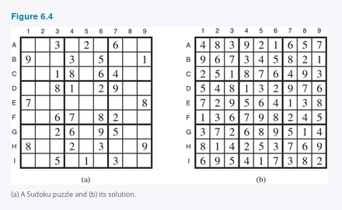

The Sudoku puzzles that appear in newspapers and puzzle books have the property that there is exactly one solution. Although some can be tricky to solve by hand, taking tens of minutes, a CSP solver can handle thousands of puzzles per second.
A Sudoku puzzle can be considered a CSP with 81 variables, one for each square. We use the variable names A1 through A9 for the top row (left to right), down to I1 through I9 for the bottom row. The empty squares have the domain
{1, 2, 3, 4, 5, 6, 7, 8, 9}
and the pre-filled squares have a domain consisting of a single value. In addition, there are 27 different Alldiff constraints, one for each unit (row, column, and box of 9 squares):
Alldiff(A1, A2, A3, A4, A5, A6, A7, A8, A9)
Alldiff(B1, B2, B3, B4, B5, B6, B7, B8, B9)
⋯
Alldiff(A1, B1, C1, D1, E1, F1, G1, H1, I1)
Alldiff(A2, B2, C2, D2, E2, F2, G2, H2, I2)
⋯
Alldiff(A1, A2, A3, B1, B2, B3, C1, C2, C3)
Alldiff(A4, A5, A6, B4, B5, B6, C4, C5, C6)
⋯
Let us see how far arc consistency can take us. Assume that the Alldiff constraints have been expanded into binary constraints (such as A1 ≠ A2) so that we can apply the AC-3 algorithm directly. Consider variable E6 from Figure 6.4(a)—the empty square between the 2 and the 8 in the middle box. From the constraints in the box, we can remove 1, 2, 7, and 8 from E6’s domain. From the constraints in its column, we can eliminate 5, 6, 2, 8, 9, and 3 (although 2 and 8 were already removed). That leaves E6 with a domain of {4}; in other words, we know the answer for E6.
Now consider variable I6—the square in the bottom middle box surrounded by 1, 3, and 3. Applying arc consistency in its column, we eliminate 5, 6, 2, 4 (since we now know E6 must be 4), 8, 9, and 3. We eliminate 1 by arc consistency with I5, and we are left with only the value 7 in the domain of I6.
Now there are 8 known values in column 6, so arc consistency can infer that A6 must be 1. Inference continues along these lines, and eventually, AC-3 can solve the entire puzzle—all the variables have their domains reduced to a single value, as shown in Figure 6.4(b).
Of course, Sudoku would soon lose its appeal if every puzzle could be solved by a mechanical application of AC-3, and indeed AC-3 works only for the easiest Sudoku puzzles. Slightly harder ones can be solved by PC-2, but at a greater computational cost: there are
255,960
different path constraints to consider in a Sudoku puzzle. To solve the hardest puzzles and to make efficient progress, we will have to be more clever.
Indeed, the appeal of Sudoku puzzles for the human solver is the need to be resourceful in applying more complex inference strategies. Aficionados give them colorful names, such as “naked triples.” That strategy works as follows: in any unit (row, column, or box), find three squares that each have a domain that contains the same three numbers or a subset of those numbers. For example, the three domains might be
{1, 8}, {3, 8}, and {1, 3, 8}.
From that we don’t know which square contains 1, 3, or 8, but we do know that the three numbers must be distributed among the three squares. Therefore we can remove 1, 3, and 8 from the domains of every other square in the unit.
It is interesting to note how far we can go without saying that this is specific to Sudoku. We do of course have to say that there are 81 variables, that their domains are the digits 1 to 9, and that there are 27 Alldiff constraints. But beyond that, all the strategies—arc consistency, path consistency, and so on—apply generally to all CSPs, not just to Sudoku problems. Even naked triples is really a strategy for enforcing consistency of Alldiff constraints and is not specific to Sudoku per se.
This is the power of the CSP formalism: for each new problem area, we only need to define the problem in terms of constraints; then the general constraint-solving mechanisms can take over.
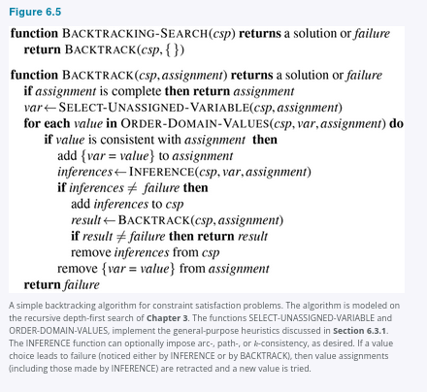

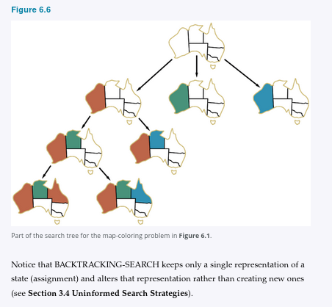

Whereas the uninformed search algorithms of Chapter 3 could be improved only by supplying them with domain-specific heuristics, it turns out that backtracking search can be improved using domain-independent heuristics that take advantage of the factored representation of CSPs. In the following four sections we show how this is done:
• (6.3.1) Which variable should be assigned next (SELECT-UNASSIGNED-VARIABLE), and in what order should its values be tried (ORDER-DOMAIN-VALUES)?
• (6.3.2) What inferences should be performed at each step in the search (INFERENCE)?
• (6.3.3) Can we BACKTRACK more than one step when appropriate?
• (6.3.4) Can we save and reuse partial results from the search?
6.3.1 Variable and value ordering
The backtracking algorithm contains the line
var ← SELECT-UNASSIGNED-VARIABLE(csp, assignment).
The simplest strategy for SELECT-UNASSIGNED-VARIABLE is static ordering: choose the variables in order, {X₁, X₂, …}. The next simplest is to choose randomly. Neither strategy is optimal. For example, after the assignments for WA = red and NT = green in Figure 6.6, there is only one possible value for SA, so it makes sense to assign SA = blue next rather than assigning Q. In fact, after SA is assigned, the choices for Q, NSW, and V are all forced.
This intuitive idea—choosing the variable with the fewest “legal” values—is called the minimum-remaining-values (MRV) heuristic. It has also been called the “most constrained variable” or “fail-first” heuristic, the latter because it picks a variable that is most likely to cause a failure soon, thereby pruning the search tree.
If some variable X has no legal values left, the MRV heuristic will select X and failure will be detected immediately—avoiding pointless searches through other variables. The MRV heuristic usually performs better than a random or static ordering, sometimes by orders of magnitude, although the results vary depending on the problem.
The MRV heuristic doesn’t help at all in choosing the first region to color in Australia, because initially every region has three legal colors. In this case, the degree heuristic comes in handy. It attempts to reduce the branching factor on future choices by selecting the variable that is involved in the largest number of constraints on other unassigned variables.
In Figure 6.1, SA is the variable with highest degree, 5; the other variables have degree 2 or 3, except for T, which has degree 0. In fact, once SA is chosen, applying the degree heuristic solves the problem without any false steps—you can choose any consistent color at each choice point and still arrive at a solution with no backtracking. The minimum-remaining-values heuristic is usually a more powerful guide, but the degree heuristic can be useful as a tie-breaker.
Once a variable has been selected, the algorithm must decide on the order in which to examine its values. The least-constraining-value heuristic is effective for this. It prefers the value that rules out the fewest choices for the neighboring variables in the constraint graph.
For example, suppose that in Figure 6.1 we have generated the partial assignment with WA = red and NT = green and that our next choice is for Q. Blue would be a bad choice because it eliminates the last legal value left for Q’s neighbor, SA. The least-constraining-value heuristic therefore prefers red to blue. In general, the heuristic is trying to leave the maximum flexibility for subsequent variable assignments.
Why should variable selection be fail-first, but value selection be fail-last? Every variable has to be assigned eventually, so by choosing the ones that are likely to fail first, we will on average have fewer successful assignments to backtrack over. For value ordering, the trick is that we only need one solution; therefore it makes sense to look for the most likely values first. If we wanted to enumerate all solutions rather than just find one, then value ordering would be irrelevant.
6.3.2 Interleaving search and inference
We saw how AC-3 can reduce the domains of variables before we begin the search. But inference can be even more powerful during the course of a search: every time we make a choice of a value for a variable, we have a brand-new opportunity to infer new domain reductions on the neighboring variables.
One of the simplest forms of inference is called forward checking. Whenever a variable X is assigned, the forward-checking process establishes arc consistency for it: for each unassigned variable Y that is connected to X by a constraint, delete from Y’s domain any value that is inconsistent with the value chosen for X.
Figure 6.7 shows the progress of backtracking search on the Australia CSP with forward checking. There are two important points to notice about this example.
First, notice that after WA = red and Q = green are assigned, the domains of NT and SA are reduced to a single value; we have eliminated branching on these variables altogether by propagating information from WA and Q.
A second point to notice is that after V = blue, the domain of SA is empty. Hence, forward checking has detected that the partial assignment
{WA = red, Q = green, V = blue}
is inconsistent with the constraints of the problem, and the algorithm backtracks immediately.

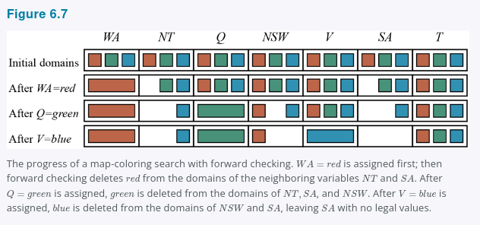

For many problems the search will be more effective if we combine the MRV heuristic with forward checking. Consider Figure 6.7 after assigning
{WA = red}.
Intuitively, it seems that assignment constrains its neighbors, NT and SA, so we should handle those variables next, and then all the other variables will fall into place. That’s exactly what happens with MRV: NT and SA each have two values, so one of them is chosen first, then the other, then Q, NSW, and V in order. Finally T still has three values, and any one of them works. We can view forward checking as an efficient way to incrementally compute the information that the MRV heuristic needs to do its job.
Although forward checking detects many inconsistencies, it does not detect all of them. The problem is that it doesn’t look ahead far enough. For example, consider the Q = green row of Figure 6.7. We’ve made WA and Q arc-consistent, but we’ve left both NT and SA with blue as their only possible value, which is an inconsistency, since they are neighbors.
The algorithm called MAC (for Maintaining Arc Consistency) detects inconsistencies like this. After a variable Xᵢ is assigned a value, the INFERENCE procedure calls AC-3, but instead of a queue of all arcs in the CSP, we start with only the arcs (Xⱼ, Xᵢ) for all Xⱼ that are unassigned variables that are neighbors of Xᵢ. From there, AC-3 does constraint propagation in the usual way, and if any variable has its domain reduced to the empty set, the call to AC-3 fails and we know to backtrack immediately. We can see that MAC is strictly more powerful than forward checking because forward checking does the same thing as MAC on the initial arcs in MAC’s queue; but unlike MAC, forward checking does not recursively propagate constraints when changes are made to the domains of variables.
6.3.3 Intelligent backtracking: Looking backward
The BACKTRACKING-SEARCH algorithm in Figure 6.5 has a very simple policy for what to do when a branch of the search fails: back up to the preceding variable and try a different value for it. This is called chronological backtracking because the most recent decision point is revisited. In this subsection, we consider better possibilities.
Consider what happens when we apply simple backtracking in Figure 6.1 with a fixed variable ordering
Q, NSW, V, T, SA, WA, NT.
Suppose we have generated the partial assignment
{Q = red, NSW = green, V = blue, T = red}.
When we try the next variable, SA, we see that every value violates a constraint. We back up to T and try a new color for Tasmania! Obviously this is silly—recoloring Tasmania cannot possibly help in resolving the problem with South Australia.
A more intelligent approach is to backtrack to a variable that might fix the problem—a variable that was responsible for making one of the possible values of SA impossible. To do this, we will keep track of a set of assignments that are in conflict with some value for SA. The set, in this case
{Q = red, NSW = green, V = blue},
is called the conflict set for SA. The backjumping method backtracks to the most recent assignment in the conflict set; in this case, backjumping would jump over Tasmania and try a new value for V. This method is easily implemented by a modification to BACKTRACK such that it accumulates the conflict set while checking for a legal value to assign. If no legal value is found, the algorithm should return the most recent element of the conflict set along with the failure indicator.
The sharp-eyed reader may have noticed that forward checking can supply the conflict set with no extra work: whenever forward checking based on an assignment X = x deletes a value from Y’s domain, it should add X = x to Y’s conflict set. If the last value is deleted from Y’s domain, then the assignments in the conflict set of Y are added to the conflict set of X. That is, we now know that X = x leads to a contradiction (in Y), and thus a different assignment should be tried for X.
The eagle-eyed reader may have noticed something odd: backjumping occurs when every value in a domain is in conflict with the current assignment; but forward checking detects this event and prevents the search from ever reaching such a node! In fact, it can be shown that every branch pruned by backjumping is also pruned by forward checking. Hence, simple backjumping is redundant in a forward-checking search or, indeed, in a search that uses stronger consistency checking, such as MAC—you need only do one or the other.
Despite the observations of the preceding paragraph, the idea behind backjumping remains a good one: to backtrack based on the reasons for failure. Backjumping notices failure when a variable’s domain becomes empty, but in many cases a branch is doomed long before this occurs. Consider again the partial assignment
{WA = red, NSW = red}
(which, from our earlier discussion, is inconsistent). Suppose we try T = red next and then assign NT, Q, V, SA. We know that no assignment can work for these last four variables, so eventually we run out of values to try at NT. Now, the question is where to backtrack? Backjumping cannot work, because NT does have values consistent with the preceding assigned variables—NT doesn’t have a complete conflict set of preceding variables that caused it to fail. We know, however, that the four variables NT, Q, V, and SA, taken together, failed because of a set of preceding variables, which must be those variables that directly conflict with the four.
This leads to a different—and deeper—notion of the conflict set for a variable such as NT: it is that set of preceding variables that caused NT, together with any subsequent variables, to have no consistent solution. In this case, the set is WA and NSW, so the algorithm should backtrack to NSW and skip over Tasmania. A backjumping algorithm that uses conflict sets defined in this way is called conflict-directed backjumping.

We must now explain how these new conflict sets are computed. The method is in fact quite simple. The “terminal” failure of a branch of the search always occurs because a variable’s domain becomes empty; that variable has a standard conflict set. In our example, SA fails, and its conflict set is (say)
{WA, NT, Q}.
We backjump to Q, and Q absorbs the conflict set from SA (minus Q itself, of course) into its own direct conflict set, which is
{NT, NSW};
the new conflict set is
{WA, NT, NSW}.
That is, there is no solution from Q onward, given the preceding assignment to
{WA, NT, NSW}.
Therefore, we backtrack to NT, the most recent of these. NT absorbs
{WA, NT, NSW} − {NT}
into its own direct conflict set {WA}, giving
{WA, NSW}
(as stated in the previous paragraph). Now the algorithm backjumps to NSW, as we would hope.
To summarize: let Xⱼ be the current variable, and let conf(Xⱼ) be its conflict set. If every possible value for Xⱼ fails, backjump to the most recent variable Xᵢ in conf(Xⱼ) and recompute the conflict set for Xᵢ as follows:
conf(Xᵢ) ← conf(Xᵢ) ∪ conf(Xⱼ) − {Xᵢ}.
6.3.4 Constraint learning
When we reach a contradiction, backjumping can tell us how far to back up, so we don’t waste time changing variables that won’t fix the problem. But we would also like to avoid running into the same problem again. When the search arrives at a contradiction, we know that some subset of the conflict set is responsible for the problem. Constraint learning is the idea of finding a minimum set of variables from the conflict set that causes the problem. This set of variables, along with their corresponding values, is called a no-good. We then record the no-good, either by adding a new constraint to the CSP to forbid this combination of assignments or by keeping a separate cache of no-goods.
For example, consider the state
{WA = red, NT = green, Q = blue}
in the bottom row of Figure 6.6. Forward checking can tell us this state is a no-good because there is no valid assignment to SA. In this particular case, recording the no-good would not help, because once we prune this branch from the search tree, we will never encounter this combination again. But suppose that the search tree in Figure 6.6 were actually part of a larger search tree that started by first assigning values for V and T. Then it would be worthwhile to record
{WA = red, NT = green, Q = blue}
as a no-good because we are going to run into the same problem again for each possible set of assignments to V and T.
No-goods can be effectively used by forward checking or by backjumping. Constraint learning is one of the most important techniques used by modern CSP solvers to achieve efficiency on complex problems.

6.4 Local Search for CSPs
Local search algorithms (see Section 4.1) turn out to be very effective in solving many CSPs. They use a complete-state formulation (as introduced in Section 4.1.1) where each state assigns a value to every variable, and the search changes the value of one variable at a time.
As an example, we’ll use the 8-queens problem, as defined as a CSP in Section 6.1 Defining Constraint Satisfaction Problems. In Figure 6.8 we start on the left with a complete assignment to the 8 variables; typically this will violate several constraints. We then randomly choose a conflicted variable, which turns out to be Q₈, the rightmost column.
We’d like to change the value to something that brings us closer to a solution; the most obvious approach is to select the value that results in the minimum number of conflicts with other variables—the min-conflicts heuristic.
In the figure we see there are two rows that only violate one constraint; we pick
Q₈ = 3
(that is, we move the queen to the 8th column, 3rd row).
On the next iteration, in the middle board of the figure, we select Q₆ as the variable to change, and note that moving the queen to the 8th row results in no conflicts.
At this point there are no more conflicted variables, so we have a solution. The algorithm is shown in Figure 6.9.
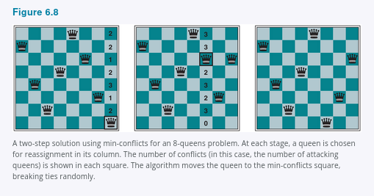

Min-conflicts is surprisingly effective for many CSPs. Amazingly, on the n-queens problem, if you don’t count the initial placement of queens, the run time of min-conflicts is roughly independent of problem size. It solves even the million-queens problem in an average of 50 steps (after the initial assignment). This remarkable observation was the stimulus leading to a great deal of research in the 1990s on local search and the distinction between easy and hard problems, which we take up in Section 7.6.3. Roughly speaking, n-queens is easy for local search because solutions are densely distributed throughout the state space.
Min-conflicts also works well for hard problems. For example, it has been used to schedule observations for the Hubble Space Telescope, reducing the time taken to schedule a week of observations from three weeks (!) to around 10 minutes.
All the local search techniques from Section 4.1 are candidates for application to CSPs, and some of those have proved especially effective. The landscape of a CSP under the min-conflicts heuristic usually has a series of plateaus. There may be millions of variable assignments that are only one conflict away from a solution. Plateau search—allowing sideways moves to another state with the same score—can help local search find its way off this plateau. This wandering on the plateau can be directed with a technique called tabu search: keeping a small list of recently visited states and forbidding the algorithm to return to those states. Simulated annealing can also be used to escape from plateaus.
Another technique called constraint weighting aims to concentrate the search on the important constraints. Each constraint is given a numeric weight, initially all 1. At each step of the search, the algorithm chooses a variable/value pair to change that will result in the lowest total weight of all violated constraints. The weights are then adjusted by incrementing the weight of each constraint that is violated by the current assignment. This has two benefits: it adds topography to plateaus, making sure that it is possible to improve from the current state, and it also adds learning; over time the difficult constraints are assigned higher weights.
Another advantage of local search is that it can be used in an online setting (see Section 4.5) when the problem changes. Consider a scheduling problem for an airline’s weekly flights. The schedule may involve thousands of flights and tens of thousands of personnel assignments, but bad weather at one airport can render the schedule infeasible. We would like to repair the schedule with a minimum number of changes. This can be easily done with a local search algorithm starting from the current schedule. A backtracking search with the new set of constraints usually requires much more time and might find a solution with many changes from the current schedule.

6.5 The Structure of Problems
In this section, we examine ways in which the structure of the problem, as represented by the constraint graph, can be used to find solutions quickly. Most of the approaches here also apply to other problems besides CSPs, such as probabilistic reasoning.
The only way we can possibly hope to deal with the vast real world is to decompose it into subproblems. Looking again at the constraint graph for Australia (Figure 6.1(b), repeated as Figure 6.12(a)), one fact stands out: Tasmania is not connected to the mainland. Intuitively, it is obvious that coloring Tasmania and coloring the mainland are independent subproblems—any solution for the mainland combined with any solution for Tasmania yields a solution for the whole map.
Independence can be ascertained simply by finding connected components of the constraint graph. Each component corresponds to a subproblem CSPᵢ. If assignment Sᵢ is a solution of CSPᵢ, then ⋃ᵢ Sᵢ is a solution of ⋃ᵢ CSPᵢ. Why is this important? Suppose each CSPᵢ has c variables from the total of n variables, where c is a constant. Then there are n/c subproblems, each of which takes at most dᶜ work to solve, where d is the size of the domain. Hence, the total work is O(dᶜn/c), which is linear in n; without the decomposition, the total work is O(dⁿ), which is exponential in n. Let’s make this more concrete: dividing a Boolean CSP with 100 variables into four subproblems reduces the worst-case solution time from the lifetime of the universe down to less than a second.
Completely independent subproblems are delicious, then, but rare. Fortunately, some other graph structures also are easy to solve. For example, a constraint graph is a tree when any two variables are connected by only one path. We will show that any tree-structured CSP can be solved in time linear in the number of variables. The key is a new notion of consistency, called directional arc consistency or DAC. A CSP is defined to be directional arc-consistent under an ordering of variables
X₁, X₂, …, Xₙ
if and only if every Xᵢ is arc-consistent with each Xⱼ for j > i.
To solve a tree-structured CSP, first pick any variable to be the root of the tree, and choose an ordering of the variables such that each variable appears after its parent in the tree. Such an ordering is called a topological sort. Figure 6.10(a) shows a sample tree and (b) shows one possible ordering.
Any tree with n nodes has n − 1 edges, so we can make this graph directional arc-consistent in O(n) steps, each of which must compare up to d possible domain values for two variables, for a total time of
O(nd²).
Once we have a directed arc-consistent graph, we can just march down the list of variables and choose any remaining value. Since each edge from a parent to its child is arc-consistent, we know that for any value we choose for the parent, there will be a valid value left to choose for the child. That means we won’t have to backtrack; we can move linearly through the variables. The complete algorithm is shown in Figure 6.11.

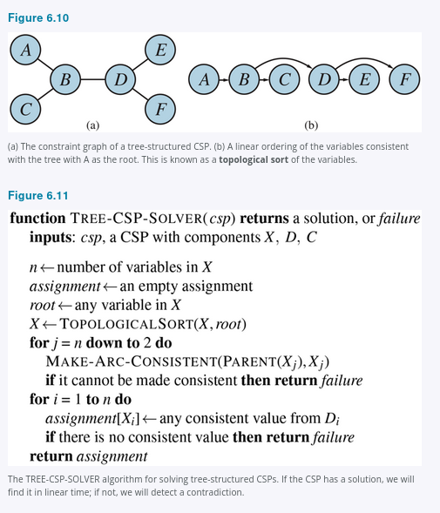

Now that we have an efficient algorithm for trees, we can consider whether more general constraint graphs can be reduced to trees somehow. There are two ways to do this: by removing nodes (Section 6.5.1) or by collapsing nodes together (Section 6.5.2).
6.5.1 Cutset conditioning
The first way to reduce a constraint graph to a tree involves assigning values to some variables so that the remaining variables form a tree. Consider the constraint graph for Australia, shown again in Figure 6.12(a). Without South Australia, the graph would become a tree, as in (b). Fortunately, we can delete South Australia (in the graph, not the country) by fixing a value for SA and deleting from the domains of the other variables any values that are inconsistent with the value chosen for SA.

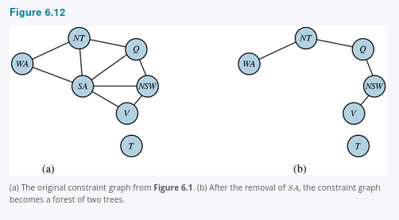
Now, any solution for the CSP after SA and its constraints are removed will be consistent with the value chosen for SA. (This works for binary CSPs; the situation is more complicated with higher-order constraints.) Therefore, we can solve the remaining tree with the algorithm given above and thus solve the whole problem. Of course, in the general case (as opposed to map coloring), the value chosen for SA could be the wrong one, so we would need to try each possible value. The general algorithm is as follows:
- Choose a subset S of the CSP’s variables such that the constraint graph becomes a tree after removal of S. S is called a cycle cutset.
- For each possible assignment to the variables in S that satisfies all constraints on S:
a. remove from the domains of the remaining variables any values that are inconsistent with the assignment for S, and
b. if the remaining CSP has a solution, return it together with the assignment for S.
If the cycle cutset has size c, then the total run time is
O(dᶜ · (n − c)d²):
we have to try each of the dᶜ combinations of values for the variables in S, and for each combination we must solve a tree problem of size n − c. If the graph is “nearly a tree,” then c will be small and the savings over straight backtracking will be huge—for our 100-Boolean-variable example, if we could find a cutset of size c = 20, this would get us down from the lifetime of the Universe to a few minutes. In the worst case, however, c can be as large as (n − 2). Finding the smallest cycle cutset is NP-hard, but several efficient approximation algorithms are known. The overall algorithmic approach is called cutset conditioning; it comes up again in Chapter 13, where it is used for reasoning about probabilities.
6.5.2 Tree decomposition
The second way to reduce a constraint graph to a tree is based on constructing a tree decomposition of the constraint graph: a transformation of the original graph into a tree where each node in the tree consists of a set of variables, as in Figure 6.13. A tree decomposition must satisfy these three requirements:
• Every variable in the original problem appears in at least one of the tree nodes.
• If two variables are connected by a constraint in the original problem, they must appear together (along with the constraint) in at least one of the tree nodes.
• If a variable appears in two nodes in the tree, it must appear in every node along the path connecting those nodes.
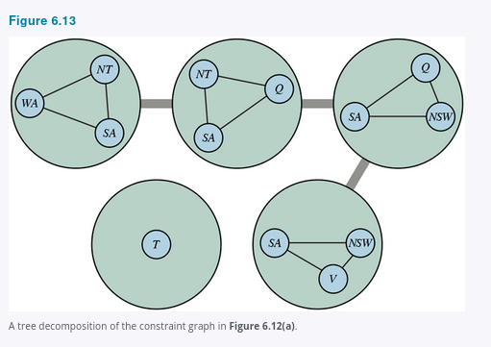
The first two conditions ensure that all the variables and constraints are represented in the tree decomposition. The third condition seems rather technical, but allows us to say that any variable from the original problem must have the same value wherever it appears: the constraints in the tree say that a variable in one node of the tree must have the same value as the corresponding variable in the adjacent node in the tree. For example, SA appears in all four of the connected nodes in Figure 6.13, so each edge in the tree decomposition therefore includes the constraint that the value of SA in one node must be the same as the value of SA in the next. You can verify from Figure 6.12 that this decomposition makes sense.
Once we have a tree-structured graph, we can apply TREE-CSP-SOLVER to get a solution in O(nd²) time, where n is the number of tree nodes and d is the size of the largest domain. But note that in the tree, a domain is a set of tuples of values, not just individual values.
For example, the top left node in Figure 6.13 represents, at the level of the original problem, a subproblem with variables
{WA, NT, SA},
domain
{red, green, blue},
and constraints
WA ≠ NT, SA ≠ NT, WA ≠ SA.
At the level of the tree, the node represents a single variable, which we can call SANTWA, whose value must be a three-tuple of colors, such as
(red, green, blue),
but not
(red, red, blue),
because that would violate the constraint
SA ≠ NT
from the original problem. We can then move from that node to the adjacent one, with the variable we can call SANTQ, and find that there is only one tuple,
(red, green, blue),
that is consistent with the choice for SANTWA. The exact same process is repeated for the next two nodes, and independently we can make any choice for T.
We can solve any tree decomposition problem in O(nd²) time with TREE-CSP-SOLVER, which will be efficient as long as d remains small. Going back to our example with 100 Boolean variables, if each node has 10 variables, then
d = 2¹⁰
and we should be able to solve the problem in seconds. But if there is a node with 30 variables, it would take centuries.
A given graph admits many tree decompositions; in choosing a decomposition, the aim is to make the subproblems as small as possible. (Putting all the variables into one node is technically a tree, but is not helpful.) The tree width of a tree decomposition of a graph is one less than the size of the largest node; the tree width of the graph itself is defined to be the minimum width among all its tree decompositions. If a graph has tree width w then the problem can be solved in
O(ndʷ⁺¹)
time given the corresponding tree decomposition. Hence, CSPs with constraint graphs of bounded tree width are solvable in polynomial time.
Unfortunately, finding the decomposition with minimal tree width is NP-hard, but there are heuristic methods that work well in practice. Which is better: the cutset decomposition with time
O(dᶜ · (n − c)d²),
or the tree decomposition with time
O(ndʷ⁺¹)?
Whenever you have a cycle-cutset of size c, there is also a tree width of size w < c + 1, and it may be far smaller in some cases. So time consideration favors tree decomposition, but the advantage of the cycle-cutset approach is that it can be executed in linear memory, while tree decomposition requires memory exponential in w.
6.5.3 Value symmetry
So far, we have looked at the structure of the constraint graph. There can also be important structure in the values of variables, or in the structure of the constraint relations themselves. Consider the map-coloring problem with d colors. For every consistent solution, there is actually a set of d! solutions formed by permuting the color names. For example, on the Australia map we know that WA, NT, and SA must all have different colors, but there are
3! = 6
ways to assign three colors to three regions. This is called value symmetry. We would like to reduce the search space by a factor of d! by breaking the symmetry in assignments. We do this by introducing a symmetry-breaking constraint. For our example, we might impose an arbitrary ordering constraint,
NT < SA < WA,
that requires the three values to be in alphabetical order. This constraint ensures that only one of the d! solutions is possible:
{NT = blue, SA = green, WA = red}.
For map coloring, it was easy to find a constraint that eliminates the symmetry. In general it is NP-hard to eliminate all symmetry, but breaking value symmetry has proved to be important and effective on a wide range of problems.

Summary
• Constraint satisfaction problems (CSPs) represent a state with a set of variable/value pairs and represent the conditions for a solution by a set of constraints on the variables. Many important real-world problems can be described as CSPs.
• A number of inference techniques use the constraints to rule out certain variable assignments. These include node, arc, path, and k-consistency.
• Backtracking search, a form of depth-first search, is commonly used for solving CSPs. Inference can be interwoven with search.
• The minimum-remaining-values and degree heuristics are domain-independent methods for deciding which variable to choose next in a backtracking search. The least-constraining-value heuristic helps in deciding which value to try first for a given variable. Backtracking occurs when no legal assignment can be found for a variable. Conflict-directed backjumping backtracks directly to the source of the problem. Constraint learning records the conflicts as they are encountered during search in order to avoid the same conflict later in the search.
• Local search using the min-conflicts heuristic has also been applied to constraint satisfaction problems with great success.
• The complexity of solving a CSP is strongly related to the structure of its constraint graph. Tree-structured problems can be solved in linear time. Cutset conditioning can reduce a general CSP to a tree-structured one and is quite efficient (requiring only linear memory) if a small cutset can be found. Tree decomposition techniques transform the CSP into a tree of subproblems and are efficient if the tree width of the constraint graph is small; however they need memory exponential in the tree width of the constraint graph. Combining cutset conditioning with tree decomposition can allow a better tradeoff of memory versus time.

